School of Digital Media & Infocomm Technology (DMIT)
ST1011 Applications Development
Practical 1.1
Introduction to Visual Studio 2015

Objectives:
After completing this lab, you should be able to:
- Familiarize yourself with Visual Studio 2015 Integrated Development Environment
- Familiarize yourself with basic I/O operations in C#.

- Launch Microsoft Visual Studio 2015.

At the main menu, choose File > New > Project.

At the "New Project" dialog, make sure "Windows" and "Console Application" are selected. Enter the following project details:
Name : MyFirstApp
Location: D:\APPD
Solution Name: MyFirstApp
Click "OK".
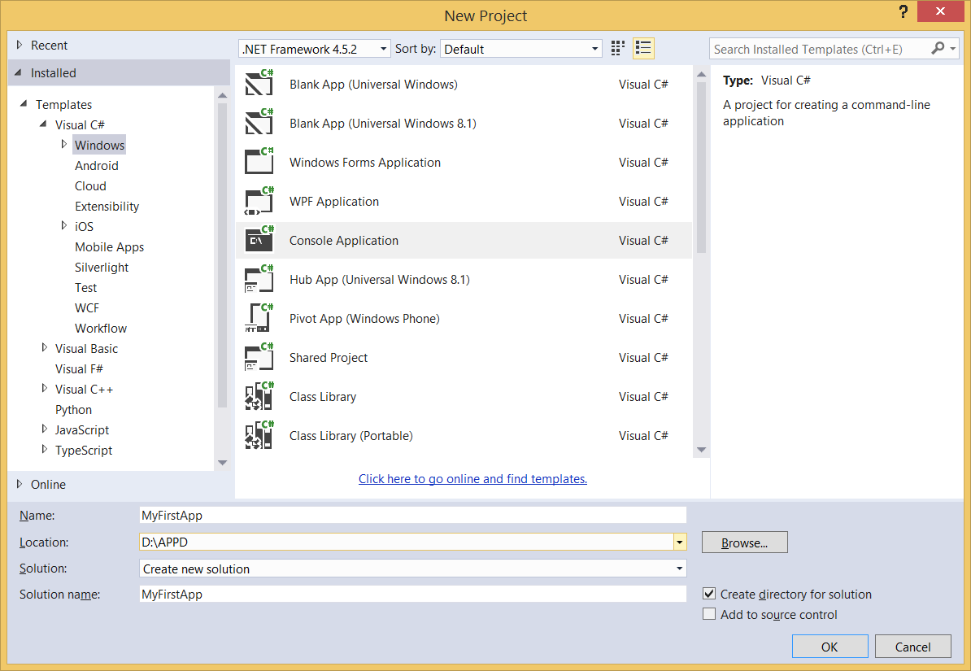

Now, you should see the following screen:
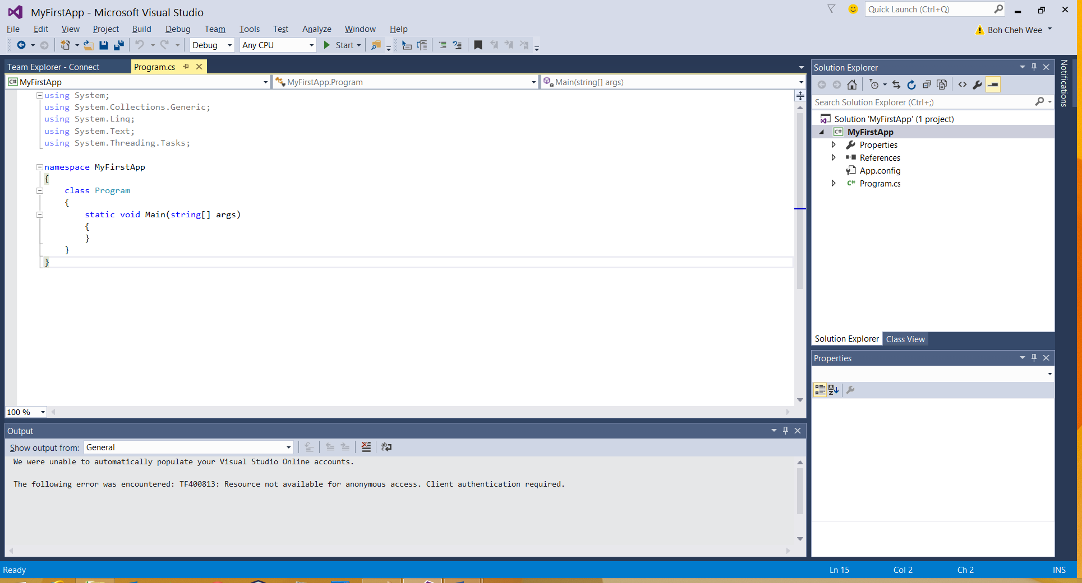
Main method

If you browse your D: drive, you will see that VS2015 has created a folder called "APPD" for you automatically, and inside the folder, there's a subfolder called "MyFirstApp". This is how you create a project in VS2015. It is recommended that all projects created in this module should always be kept in D:\APPD.
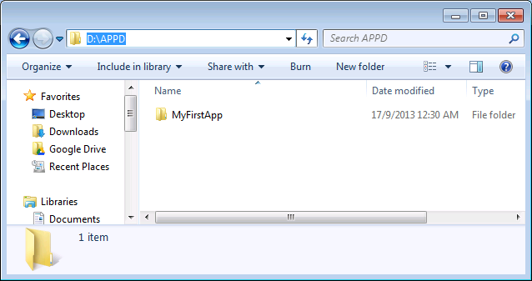

Now, back at VS2015 window, enter the following codes into the main method.

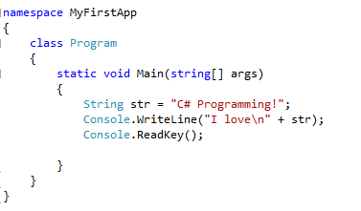

Run the program by clicking button located at the Toolbar (top of the screen). The following output command dialog should pop up:
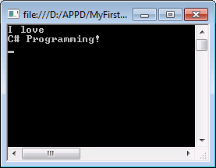

Press any key on your keyboard to close the output dialog or simply click "Stop" () button at the toolbar to stop the running program.

Click "Save" or "Save All" () to save your project. Note that every time you run your program, the project should automatically be saved by VS2012.

From main menu, choose File > Close Solution to close the C# project.
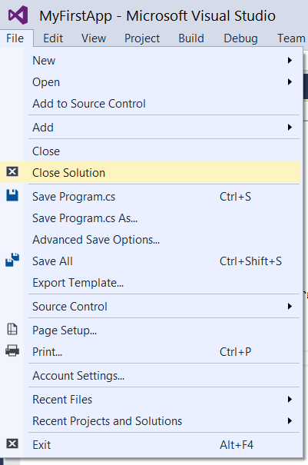

Program Explanation:
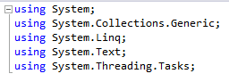
This is the namespace declaration section. Namespace is equivalent to "package" in Java, and the keyword "using" is the same as "import" in Java. For example, using System;, indicates that you are referencing the System namespace. Namespaces contain groups of code that can be called upon by C# programs. With the using System; declaration, you are telling your program that it can reference the code in the System namespace without pre-pending the word System to every reference.

As mentioned earlier, namespace is just like 'package' in Java. We use namespace to organize a group of assemblies, classes, or types. A namespace acts as a container like a disk folder -for classes organized into groups usually based on functionality.

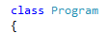
Well, again just like Java, C# program is written in a class. The class declaration, class Program, contains the data and method definitions that your program uses to execute.

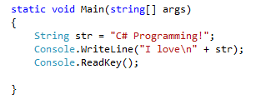
This is the main method of the Program class. Every C# application must contain a single Main method specifying where program execution is to begin. In C#, Main is capitalized, while Java uses lowercase main.

- Create another project called "TestIO".

 | Note that VS2015 only allows you to have 1 class in a project with the Main method. If you try to add a new class to your existing project, the moment you add a Main method into that new class, there will be an error.

Enter the following codes into the main method:
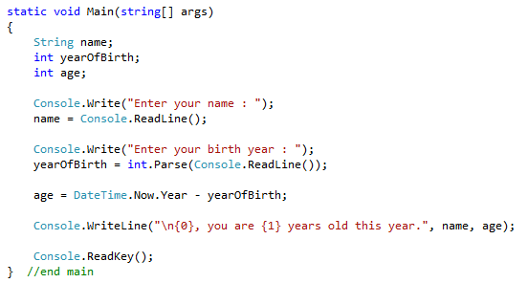
Save and run the program to see what this program does.

Question:
- What is Console.WriteLine()?
- What is the difference between Write() and WriteLine() methods?
- What is Console.ReadLine()?
- What is Console.ReadKey()? What is going to happen if this statement is missing?

- END -

